Exercise 1: Implementing the Singleton Pattern
Scenario:
You need to ensure that a logging utility class in your application has only one instance throughout the application lifecycle to ensure consistent logging.
Code:
class Logger {

// Private static instance
private static Logger instance;

// Private constructor
private Logger() {
System.out.println("Logger instance created.");
}

// Method to get the single instance
public static Logger getInstance() {
if (instance == null) {
instance = new Logger();
}
return instance;
}

// Logging method
public void log(String message) {
System.out.println("Log: " + message);
}
}

public class SingletonTest {

public static void main(String[] args) {

Logger logger1 = Logger.getInstance();
Logger logger2 = Logger.getInstance();

logger1.log("Application started.");
logger2.log("User logged in.");

if (logger1 == logger2) {
System.out.println("Only one Logger object is created.");
} else {
System.out.println("Multiple objects created.");
}
}
}

Output:
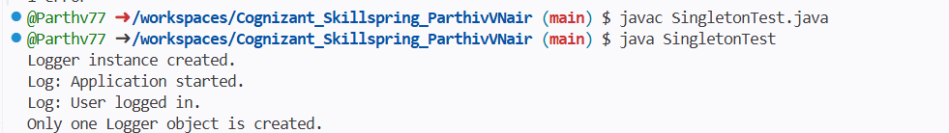

Exercise 2: Implementing the Factory Method Pattern
Scenario:
You are developing a document management system that needs to create different types of documents (e.g., Word, PDF, Excel). Use the Factory Method Pattern to achieve this.
Code:
interface Document {
void open();
}

class WordDocument implements Document {
public void open() {
System.out.println("Opening Word Document.");
}
}

class PdfDocument implements Document {
public void open() {
System.out.println("Opening PDF Document.");
}
}

class ExcelDocument implements Document {
public void open() {
System.out.println("Opening Excel Document.");
}
}

abstract class DocumentFactory {
abstract Document createDocument();
}

class WordFactory extends DocumentFactory {
public Document createDocument() {
return new WordDocument();
}
}

class PdfFactory extends DocumentFactory {
public Document createDocument() {
return new PdfDocument();
}
}

class ExcelFactory extends DocumentFactory {
public Document createDocument() {
return new ExcelDocument();
}
}

public class FactoryTest {

public static void main(String[] args) {

DocumentFactory wordFactory = new WordFactory();
Document word = wordFactory.createDocument();
word.open();

DocumentFactory pdfFactory = new PdfFactory();
Document pdf = pdfFactory.createDocument();
pdf.open();

DocumentFactory excelFactory = new ExcelFactory();
Document excel = excelFactory.createDocument();
excel.open();
}
}
